Part one
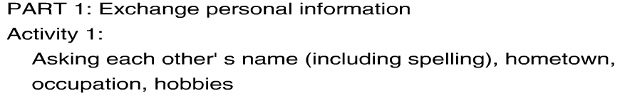（必考题）
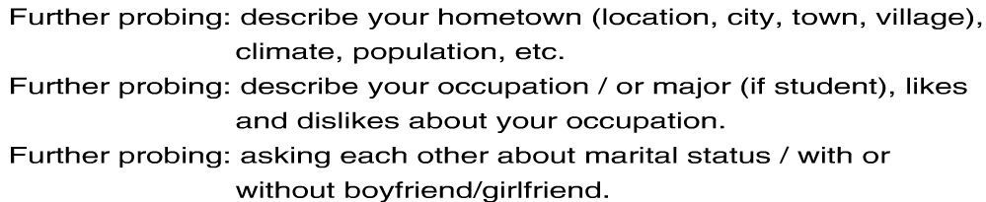
I am a kind of person who can balance well between my personal life and woke life

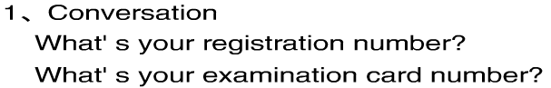
Here you are/ that is okey.
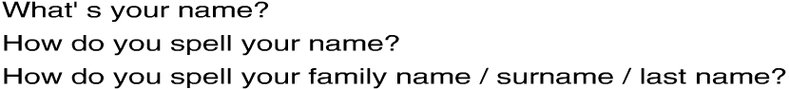
(姓) 名：second name /given name


西方人选择城市的十大目标：
Weather transportation environment housing(pricey/expensive/costly) night life local people（hospitable /friendly/ generous） night life
Local government

Job opportunities, resorts, atmosphere

常考题：
- transportation
How did you come here today? How did you travel to the test? Did you come here by bus?
Bus / taxi / cab / private car / subway / Tube underground / tram

If you could travel by any form of transport you want, what would you choose? (Why?)
Which form of transport would you like to travel by? time / safety / money

How do you think you will travel to work in 15 years’ time?
How do you think you will travel to work 15 years from now?
Ans:
It would be fast developing in 15 years time and will cover everywhere in Beijing. It will be really convenient.

(2) Hotels
What kind of accommodation do you usually stay in when you go on holiday?
- hotel/motel/villa/apartment/flat(BrE)/dorm
- city breaks, beach holidays
sun-tanned / fast-tanned center

Do you stay in a hotel or an apartment you are on holiday?
- camping camp or tent
- Hitchhiking, hitchhiker (take a gap year)
- Domestic travel
- Sight seeing

What kinds of facilities do you think hotels ought to provide for business people? (Why?)
- Hi-tech, Local Area Net, internet, database system, fax
- Well equipped conference room,
sound-proof
multi-function hall
video-conferencing, tele-conferencing

Do you think companies should pay for their staff to stay in expensive hotels on business trips? (Why? / Why not?)

It depends (on the different circumstances).
If you fix a deal which is worth $1000000, in that case, your company will pay for you to live…
If you go there for only $2, it’s impossible.

(3)Job (important )
What kind of job would you like to do most? (Why?) What would your ideal job be?
What kind of job do you like?
Job title Job responsibility Job satisfaction

Should companies offer training to staff?
(Why? / Why not?)
Do you think companies should provide training for staff?

- training→productivity→profit→motivation
But: training→cost money, time, staff
opportunity cost internal conflict
Would you like to work abroad? (Why? / Why not?)
Is the opportunity to work in another country important to you?

- broaden one’s horizon, experience
- …is quite an experience to me.
- …is a real eye-opener culture messenger

(4)Training Course (在第2部分和第3部分中非常重要)
What kind of training course have you ever taken?
Have you ever taken any training course?

NewOriental School BEC online training course Computer skill training course

What do you think is most important when you choose a training course? (Why?)

Location Transportation Duration of course Cost
Flexibility of trainer Topics covered Materials Follow up advice

(5) Future Plan
What would you like to do after you finish your studies? (Why?)
- go abroad, look for a job, hunt for a job, study further, post graduate

What are you doing now for the preparation of your future plan?
- knowledge preparation: attend training course
- psychological preparation: be mature
improve interpersonal skills

What if you failed to find a job as a…? I am the right person for this job

(6) Teamwork（外企应聘必考题）
What kind of people do you most like working /studying with? (Why?)
- Honest and have good interpersonal skills diversity

What do you think makes a good team? What is a good team?
Cooperation and friendly atmosphere
Mutual trust

Do you think you work in a good team? (Why? / Why not?)

Asking about personal views.

- Why do you study English?
- Why do you want to study business?
- What do you think of some modern methods of payment (credit cards, cheques, bank transfers)?
- What role does the computer play in modern business?
- What are some necessary steps for preparing a business trip overseas?
- Which kind of office would you prefer to work in, cellular or an open-plan office?
- What do you think of international trade?
- How to deal with customer enquires on the phone?
- Transportation: (What is your usual means of transportation? Compare the various means of transportation)
- Health and safety in the workplace (How to ensure a healthy working environment for employees? What are some health hazards in the office/factory shop? What safety measures should be adopted in the workplace?)
- How to keep a balance between growth and environment protection?
- Radio and TV (What are your favorite/TV programs? Why?)
- What kind of role does advertising play in promoting your products/services? Which form of advertising is most effective in your opinion?
- What are the required qualities of a modern manager?
- What do you know about flexible time?

Life English
Talking about money
1．
If you have money, you can easily make money.
Money makes money.
Money begets money.

If you are in debt, you lose your self-respect.
You lose your motivation.
Your debt continues to grow.

You start to worry.
You need to borrow more money.
You get even deeper in debt.

2.
Money comes.
Money goes.
But the memory is always there.

Money talks.
Money rules.
Money is power.

3.
Money burns a hole in your pocket.
It goes out as fast as it comes in.
You’re a spendthrift.

Don’t squander your hard-earned money.
Put your savings in the bank.
Never live beyond your means.

Be a good consumer.
Be a smart shopper.
Be a clever buyer.

Tongue Twister
- Good cookies could be cooked by good cook if a good cook could cook good cookies.
- If you understand, say understand.
If you don’t understand, say don’t understand.
If you understand say you don’t understand.
How can I understand you understand.
Understand?
- Peter Pipe picked a peck of pickled peppers prepared by his parents and put them on a large paper plate.

Ⅲ Business Dialogue

1) Negotiating a Job Offer
Employer: would you consider an offer of $56,000 per year?
Ms. Wilson: What kind of benefits are talking about?
Employer: Our standard package includes health insurance, two weeks vacation and a company car.
Ms. Wilson: Are these things negotiable?
Employer: Uh…not normally. What do you have in mind ?
Ms. Wilson: Vacation time is important to me. I would be willing to give up these other items in order to receive more vacation days.
Employer: What an interesting idea, Ms. Wilson. Would you also be willing to accept a cut in initial salary?
Ms. Wilson: possibly. What do you have in mind ?

2) Employee Pay Raise

Boss: You have done an excellent job this year and we are pleased with the results.
Employee: I am glad that you have been happy with my performance.
Boss: As a result of your performance, we happy to offer you the position of manager.
Employee: Does this title come with an increase in salary?
Boss: Yes, it does.
Employee: Can you give me the specifics?
Boss: Your monthly gross salary will increase by $500.
Employee: That sounds fair.

3） Asking for a Raise

Mr. White: So, tell me: what makes you think we should give you a raise?
Miss Small: I’ve got several good reasons. I’ve been here several years, my work has proven to be good, and I’ve noticed that people in comparable jobs get paid more than I do.
Mr. White: Salaries are confidential; how do you know how much money these “other people” make?
Miss Small: Well, I’ve noticed all the new cars around here, for one thing.
Mr. White: Those are company cars provided to the sales staff for their business trips. Also, some employees receive sales commissions. So good salesmen will naturally earn more.
Miss Small: That’s understandable. Well, rather than comparing my salary with someone else’s, perhaps we could talk about my job performance. Surely you’ve noticed the extra hours I’ve put in recently? If I were being paid an hourly wage, with the standard time – and – a – half for overtime, I’d be earning much more.
Mr. White: I see you point. However, it might be hard to get a raise approved. Profits were down last quarter, and the whole company is tightening its belt, so anything that affects the annual budget is hard to get approved. But I’ll tell you what I’ll do. I’ll give you a one – time bonus for your recent hard work. And I’ll try to arrange some sort of compensation for any future overtime.
Miss Small: That would be very good of you, Mr. White.

- Asking for a Raise

Martin: Mr. Smith, I have been doing some industry research and was shocked to learn that the average salary for a position that is similar to mine pays, on average $2,000 more per year than I am currently making.
Mr. Smith: What are you basing this information on?
Martin: First and secondary research. I hope that you can address this concern immediately as I find it very disturbing.
Mr. Smith: Yes, I will. We are very happy with performance and want to continue our good working relationship.
Martin: I wish the same. As such, I hope you will seriously consider a pay increase.
Mr. Smith: Let me take this up with the Director and get back to you immediately.

